**Sample Implementation Plan for Password Reset Feature**

A password reset email should be sent upon request of a user to reset their password in the event they have forgotten it.

1. **Deliverables**

* Create an endpoint for sending a password reset email.
* Create an endpoint for resetting the password by allowing a user to set a new password and confirm it.

1. **Mockups**

The following is a mockup that was prepared solely for the sprint demo session that visually describes how the functionality of the task will be envisioned by a user. The link to the mockups can be accessed [here](https://wireframepro.mockflow.com/view/Mf36c9c241687e2ac10b3259564b0caf11549610080941#/page/de52daa7c26e4ab199817415b4737be4).

**The endpoint for sending password reset email:**

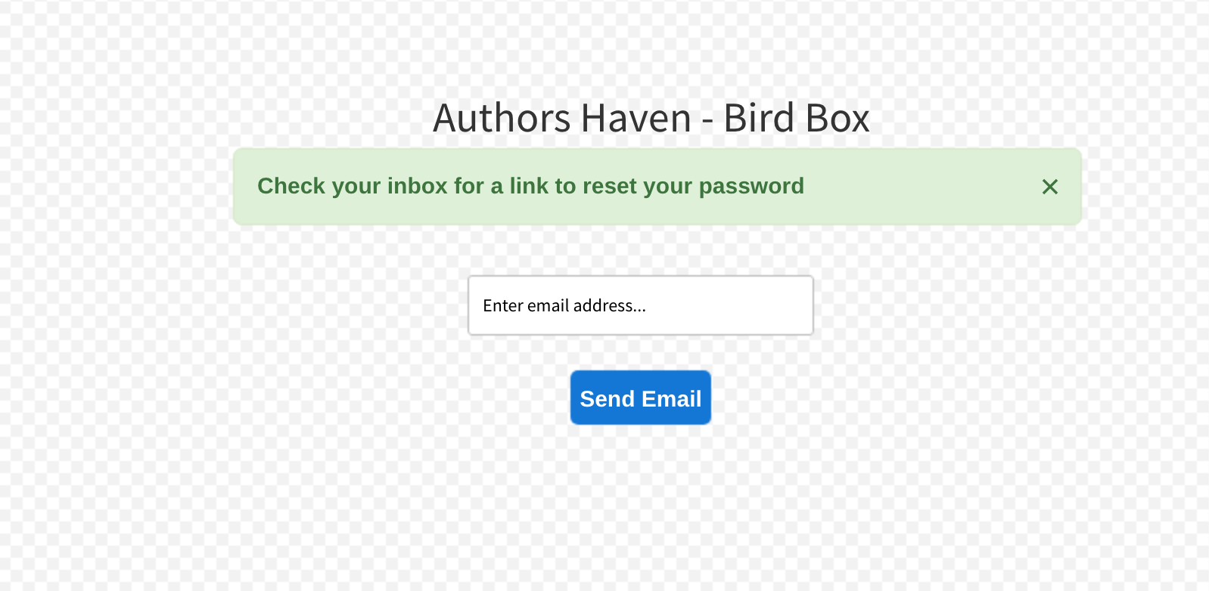

**The endpoint for setting the new password and confirming it:**

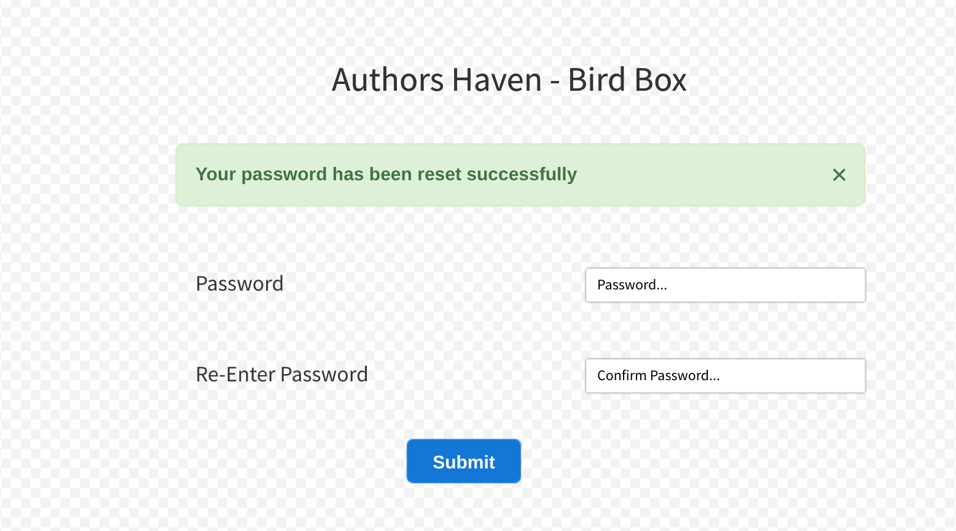

1. **Flowchart**

The following flowchart is a graphical representation of the steps taken for a successful password reset via email.

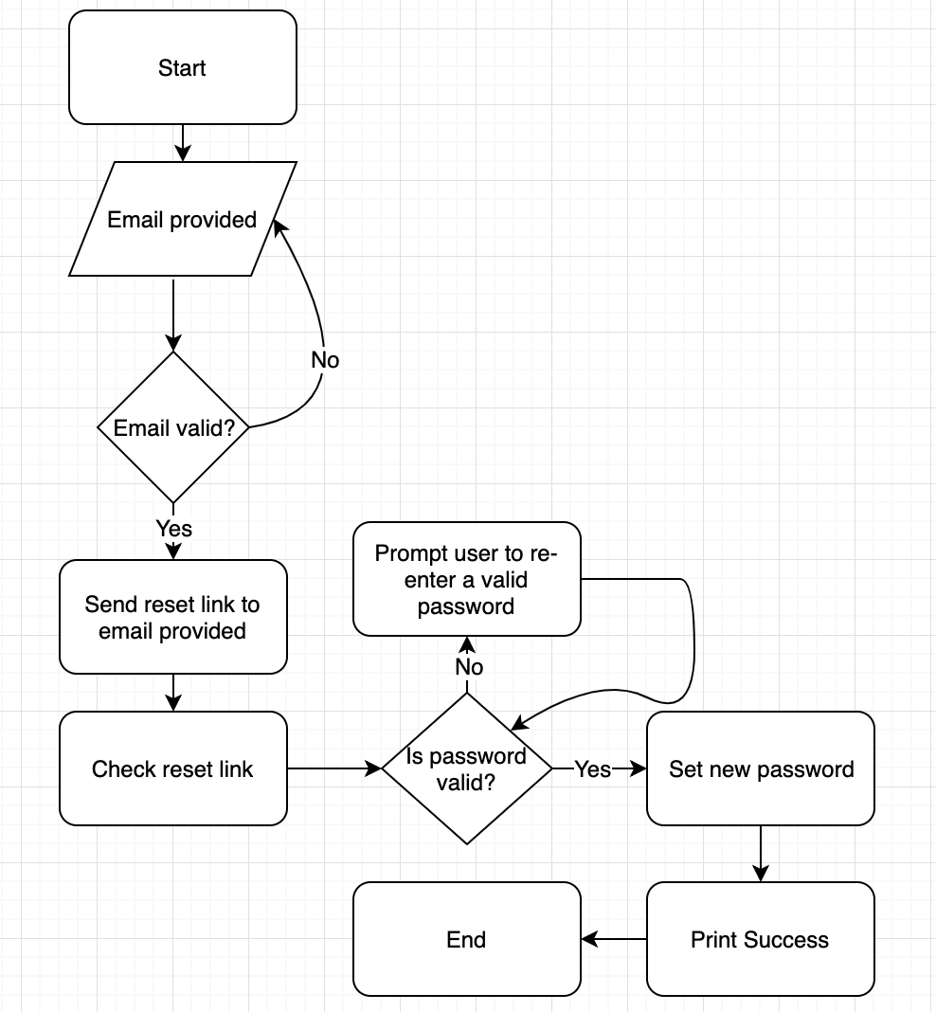

1. **Schedule of the implementation of the task**

* Have the tests of the feature written by Monday the 4th of February 2019.
* Have the endpoint that sends the password reset link to the valid email by Tuesday 5th of February 2019.
* Have the endpoint through which the user is allowed to set and confirm a new password by Wednesday 6th of February 2019.
* Refactor the tests to pass by the Thursday 7th of February 2019 and work on any given feedback given on the PR.
* Polish up the work and ensure my PR gets merged before the morning of Friday 8th of February 2019.

1. **Blockers/Foreseen blockers from team members**

None

**Changes to the Document**

1. **Mockup Designs** 
   1. **Mockups Iteration 2**

<new designs here>

* 1. **Final Mockup Design**

<final designs here>

1. **Actual timeline for the feature**

The actual timeline for the feature is as follows:

* Tests of the feature were written by Monday the 4th of February 2019.
* Endpoint that sends the password reset link to the valid email was ready on Tuesday the 5th of February 2019.
* The endpoint through which the user is allowed to set and confirm a new password was ready on Thursday 7th of February 2019.
* Refactored the tests to pass on Thursday the 7th of February 2019 and worked on feedback given on the PR.
* PR got merged on the morning of Friday the 8th of February 2019.

The change in the timelines for delivery of the feature was due to the following:

* I faced a blocker with the password reset endpoint which kept morphing the redirect URL. This delayed the delivery of the feature by 1 day.